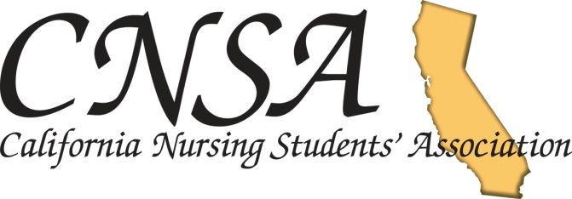

Fundraising Toolkit: Tips for Success!
By: Danielle Apuntar, CNSA Fundraising Director
San Diego State University, School Of Nursing

A Fundraising Director should be someone who has the passion, creativity, and sees the position as more than just a responsibility!
One of the most important concepts in fundraising is to constantly research for new products.
Online searching
Local vendors in your area
National and State Convention
Even your very own bookstore
Organize a binder with a monthly fundraising timeline
When doing events/activities, pick a date and time that is convenient. It is best to choose a
date after a big test so that you have more people to sign up to volunteer.
Keeping a record of previous activities helps with future events so that things that have
failed in the past are not repeated.
The binder can consist of a list of contact information of people you previously and
currently work with, sketches/mock-ups of designs, vendors, websites and ideas
The binder also helps transition the next Fundraising Director as this is passed on

Creating merchandise
It’s all about budget and product revenue! Look for cheap wholesale with items with quality. Your overall goal is to spend as little as possible and make as much money as possible
Always consult with the treasure regarding your budget.
Inquire other stores (mainly your local bookstore) and see competing prices
Example: License plates in your bookstore are being sold for $20-$25.
Look for a company that sells it for a wholesale price of $10-$12 and sell for $22. Make sure you find a company that fits YOU best. Some companies would have a wholesale price of $10 each, but with a minimum order of 500 license plates.

Make a web-page
Create a page where students can see available merchandise
SDSU CNSA has a Facebook page:
http://www.facebook.com/#!/pages/California-Nursing-Students-Association- SDSU-chapter/115582508476447

Suggestive Selling
Promote your product! Love it, Wear it, and Sell it.
Give a person a reason why they should and must have this item
Ex: “Our school of nursing polo is really useful throughout nursing school. It’s a on the go item that you can wear in all or most of your semesters of nursing school. It’s convenient in picking out your patients, during your community health rotation, going to a conference, and nursing conventions. In the long run it will save you time and money as polo shirts are considered professional looking”
Ex: Nursing Bag: Really durable with a ton of capacity (List what it can fit) Appeal to ethos such as “Before I got into nursing school, I always see students walking around with their bags and was always jealous that I wasn’t in yet. Now, you guys finally are in and you completely deserve it”
When holding an event to sell your product, make sure you have sample sizes so that people can try them
on.

Expanding your business
Also appeal to those who will graduate. Make merchandise for alumni students.
It can be as simple as adding the word “Alumni” to the item
Family members as well (SDSU MOM, SDSU DAD)

Pre-Order
The best and most trusting way to fundraise merchandise is pre-ordering. Pre-ordering is a good way to secure that the person will be buying the merchandise. In the past, there are some who will order first and when the item comes, they decide to not want it or want to exchange for another item that you may not have in stock. Having to order first than pre-order is a hassle and at the same time, you lose profit. In addition, you have money up-front to buy the item when pre-ordering

List of things that San Diego State CNSA has done in the past and present.
Merchandise (Includes Alumni products)
Zip-Up Sweaters
Pullover Hoodies
Crew Necks
Half Zip Sweaters
Shirts
Mugs
Badge Reels
Charms
Sweatpants
Frames
License plates
Nurse Bears
Bags
Bumper Stickers

Events
New Student Orientation (Our biggest profit maker)
Pinning Ceremony for graduate students
Semester Merchandise Event

Local Fundraising
On campus food places
Daphne’s
Panda Express
Rubio’s
Yogurt land
Del Mar Mud Run
Hot Chocolate 15K

Misc
Recycling Program

