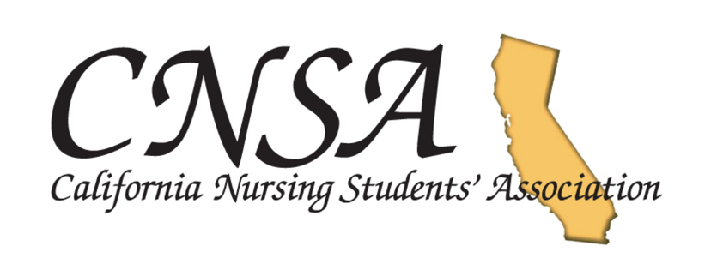
News from CNSA: Email Broadcast (April 2018)

In this Broadcast:
- Membership Meeting North Save the Date!
- The Official CNSA Honor Cord is here!
- CPR Block Party Chapter Challenge
- Read the Range of Motion (Winter 2018)
- CNSA Text Alerts: Now Available
- Follow our Social Media – Win a Gift Card!
  - Instagram
  - Facebook
  - Twitter
- Chapter Spotlight: Our Outstanding Members at Work
  - Sonoma State University
- Get Involved: Join A Committee Today!

- Membership Meeting NORTH. Save the date!!
Pencil this in, June 2 at Samuel Merritt University in Oakland. Stay updated click here .

- The Official CNSA Honor Cord is here!
The CNSA Honor Cord reflects your dedication and achievements during nursing school as an active participant in your transition to become a nursing professional. Wear them with pride to signify your membership and accomplishment in a student-run organization that spans your school, the state of California and the nation. Orders must be placed by April 23rd 2018 and will be shipped before the end of May. ORDER NOW! Click here.

- CPR Block Party Chapter Challenge
CNSA chapters across California are invited to host their own CPR Block Parties between the dates of April 23rd and April 30th. The chapters will submit verification forms detailing how many people they trained in hands-only CPR during that time. Click here.

The Chapter that trains the most people will win a grand prize of $3,000 and the runner-up will win a prize of $1,000. Winners will be showcased on CNSA social media, the CNSA website and the next Range of Motion publication.

- Read The Latest Range of Motion
The most current and up-to-date issue of our newsletter. Click here

- Sign Up For CNSA Text Alerts!
Text “CNSA MEMBER” to 84483 to receive text alerts from CNSA

- Follow us on our Social Media
- Instagram: c.n.s.a_
- Facebook: California Nursing Students Association (CNSA)
- Twiter: CNSA_California

- Chapter Spotlight
Long Beach City College. Click here.

- Join A Committee
Interested to be more involved with CNSA? Join a committee! Click here for more information and about specific committees and their respective responsibilities.

