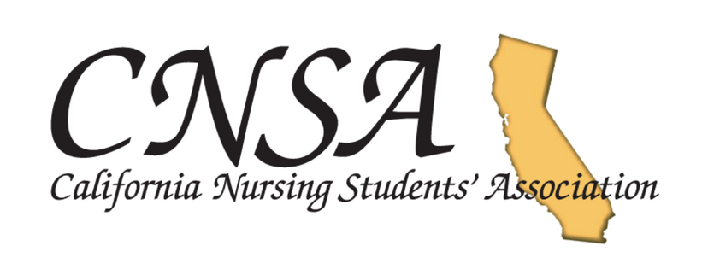
News from CNSA: Email Broadcast (May 2018)
In this Broadcast:
- Membership Meeting North is Fast Approaching!
- Lux on Her Side Donation
- CNSA Text Alerts: Now Available
- Follow our Social Media – Win a Gift Card!
  - Instagram
  - Facebook
  - Twitter
- Chapter Spotlight: Our Outstanding Chapters at Work
  - National University; San Diego
- Member Spotlight: Allison Calderon
- Get Involved: Join A Committee Today!

- Membership Meeting NORTH is this coming weekend, June 2. Register NOW!
This is an event that you would not want to miss! To pre-register, go to
https://form.jotform.com/CalNursingStudentsAssociation/cnsa-membership-meeting-north

For meeting agenda, refer to the last page of this document or go to www.cnsa.org

- Lux on Her Side Donations
A statewide feminine hygiene product drive. Please bring your donations to Membership Meeting North this coming Saturday, June 2, 2018 at Samuel Merritt University. http://www.cnsa.org/assets/lux%20on%20her%20side.pdf

- Sign Up For CNSA Text Alerts!
Text “CNSA MEMBER” to 84483 to receive text alerts from CNSA

- Follow us on our Social Media
- Instagram: c.n.s.a_
- Facebook: California Nursing Students Association (CNSA)
- Twiter: CNSA_California

By using #cnsa2018, you will be automatically entered for a chance to win a gift card!

- Chapter Spotlight
National University, San Diego. http://www.cnsa.org/assets/nusna.png
To be featured, tag us on your chapter events and activities! Or use #cnsa2018

- Member Spotlight
Allison Calderon http://www.cnsa.org/assets/allison.png

To be featured on our next Member Spotlight and win a Starbucks gift card, make sure to tag us or use #cnsa2018

- Join A Committee
Interested to be more involved with CNSA? Join a committee! Click here for more information and about specific committees and their respective responsibilities.

